Ideation Phase

Define the Problem Statements

|  |  |
| --- | --- |
| Date | 19 September 2022 |
| Team ID | PNT2022TMIDxxxxxx |
| Project Name | Project – Classification of Arrythmia by using Deep Learning with 2-D ECG Spectral Image Representation |
| Maximum Marks | 2 Marks |

# Customer Problem Statement Template:

Create a problem statement to understand your customer's point of view. The Customer Problem Statement template helps you focus on what matters to create experiences people will love.

A well-articulated customer problem statement allows you and your team to find the ideal solution for the challenges your customers face. Throughout the process, you’ll also be able to empathize with your customers, which helps you better understand how they perceive your product or service.

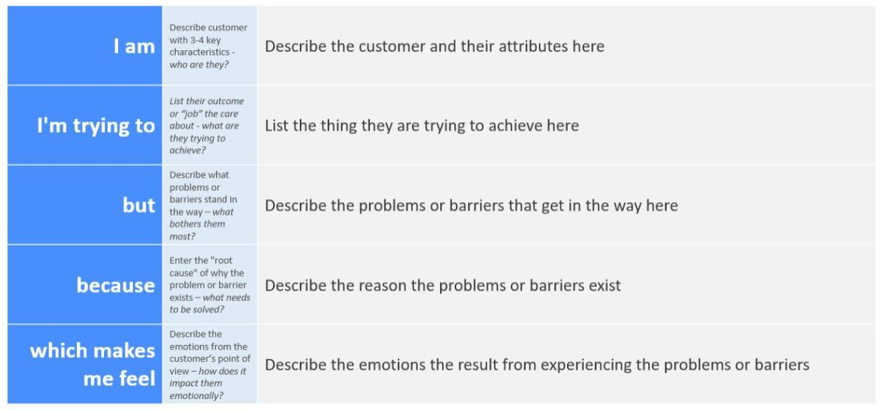

Reference: <https://miro.com/templates/customer-problem-statement/>

# Example:



|  |  |  |  |  |  |
| --- | --- | --- | --- | --- | --- |
| **Problem**  **Statement (PS)** | **I am**  **(Customer)** | **I’m trying to** | **But** | **Because** | **Which makes me feel** |
| PS-1 | A Patient | Select an Image to Upload | It takes long time to upload | The Mobile version is slow | Annoyed |
| PS-2 | Doctor | Diagnose the Arrythmia | ECG with variations have  Same problem | Arrythmia is classified only by small variation | Frustrated |